**TECHNOLOGY ARCHITECTURE:**

**DATABASE**

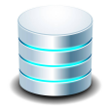

**USER**

**SYSTEM**



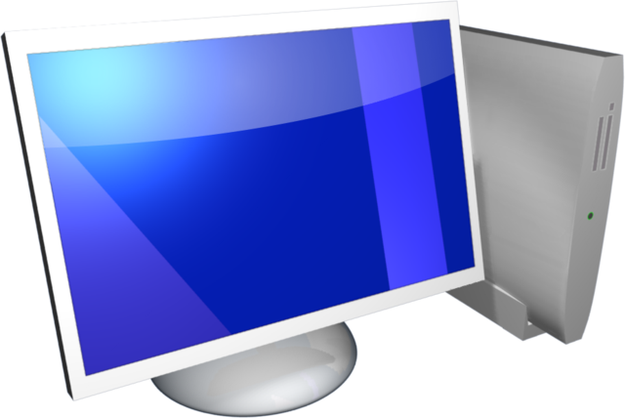

Send mail alert if less stock

Stock details store in database



**SEND GRID**

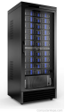

**SERVER**